Advanced Learners 2021-22
PG DEPARTMENT OF HINDI
Name of Student | College Roll No. | Class | Marks in University Exams/House Tests in Previous year/Semester | Member of any society/ organization etc. | Measures Taken/opportunities given to Further enhance skills and confidence of the students | Achievements/ Outcome | Proof of the achievement/ outcome
Janvi | 10578 | B.A- I Sem | 18/20 | - | Regular Class Test,Assignments, Seminars, Presentations , etc | 82/100 | 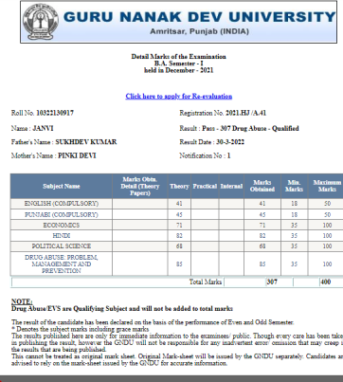
Isha | 10581 | B.A- I Sem | 16/20 | - | Regular Class Test,Assignments, Seminars, Presentations , etc | 86/100 | 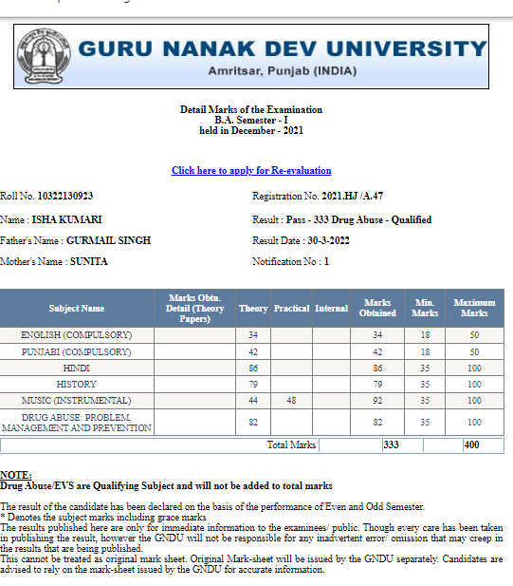
Janvi | 10578 | B.A- II Sem | 18/20 | - | Regular Class Test,Assignments, Seminars, Presentations , etc | 76/100 | 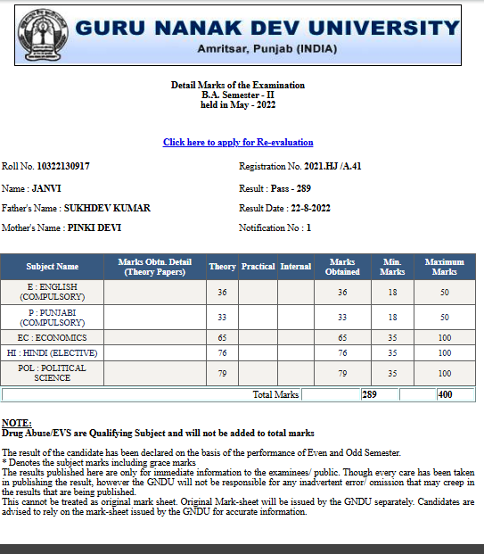
Bhumika | 10671 | B.A- II Sem | 17/20 | - | Regular Class Test,Assignments, Seminars, Presentations , etc | 70/100 | 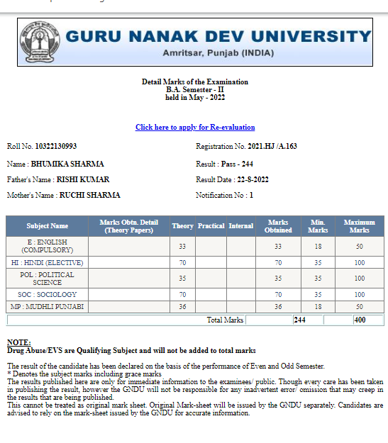
Mehak | 10019 | B.A –III Sem | 16/20 |  | Regular Class Test,Assignments, Seminars, Presentations , etc | 84/100 | 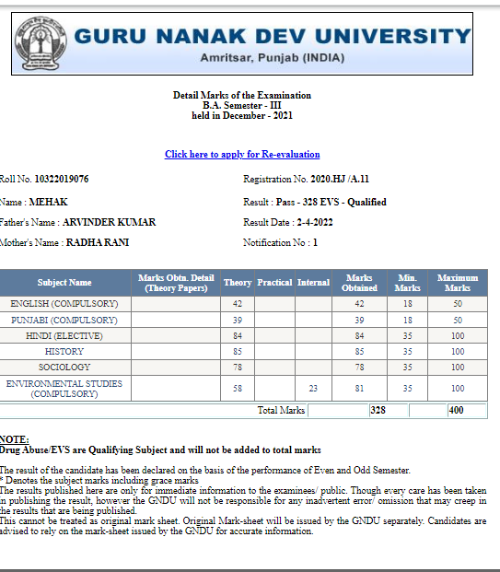
Kirti | 10011 | B.A –III Sem | 17/20 |  | Regular Class Test,Assignments, Seminars, Presentations , etc | 83/100 | 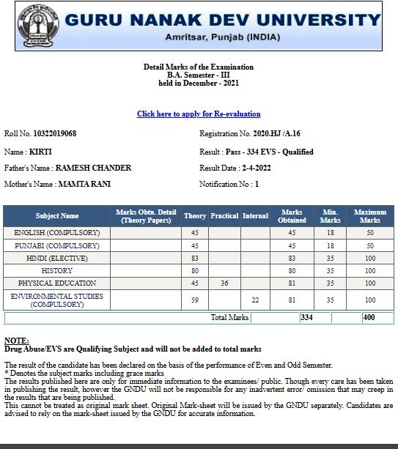
Kirti | 10011 | B.A – IV Sem | 16/20 |  | Regular Class Test,Assignments, Seminars, Presentations , etc | 76/100 | 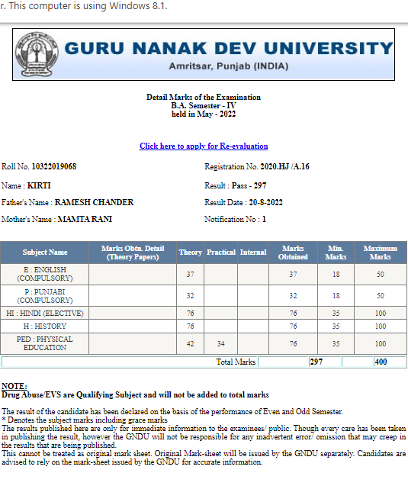
Rohini | 10076 | B.A – IV Sem | 17/20 |  | Regular Class Test,Assignments, Seminars, Presentations , etc | 72/100 | 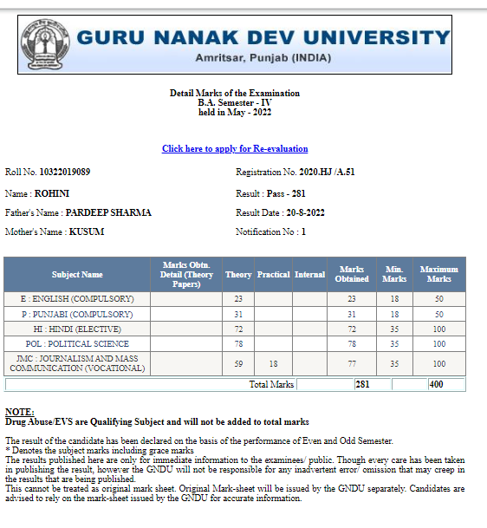
Tamana | 6005 | B.A –Vth sem | 18/20 | - | Regular Class Test,Assignments, Seminars, Presentations , etc | 91/100 | 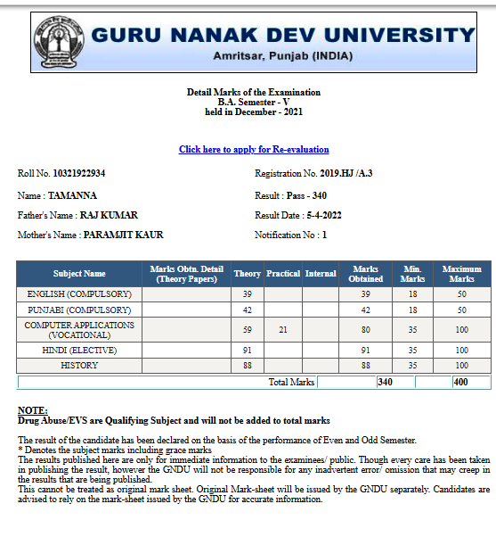
Sakshi | 6061 | B.A –Vth sem | 16/20 | Hindi Sahitye Parishad | Regular Class Test,Assignments, Seminars, Presentations , etc | 90/100 | 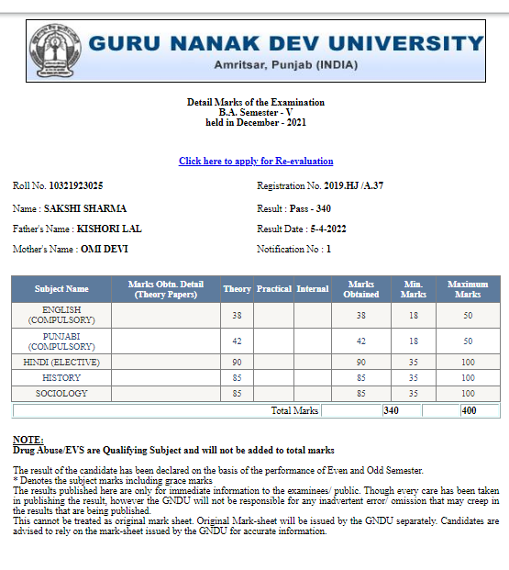
Kaveri | 6083 | B.A –VIth sem | 15/20 |  | Regular Class Test,Assignments, Seminars, Presentations , etc | 78/100 | 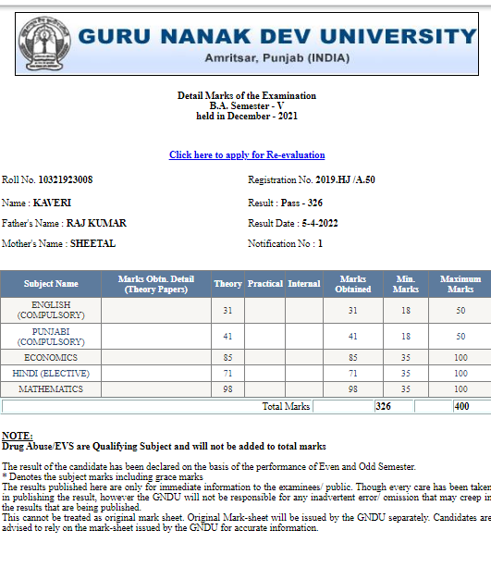
Deepa Sharma | 6143 | B.A –VIth sem | 17/20 |  | Regular Class Test,Assignments, Seminars, Presentations , etc | 80/100 | 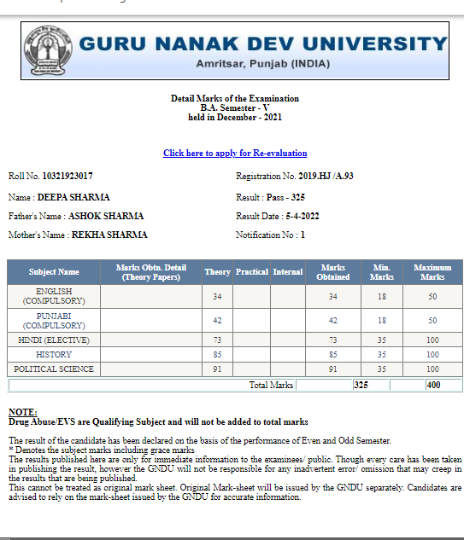
Tamana | 6005 | B.A –VIth sem | 16/20 |  | Regular Class Test,Assignments, Seminars, Presentations , etc | 77/100 | 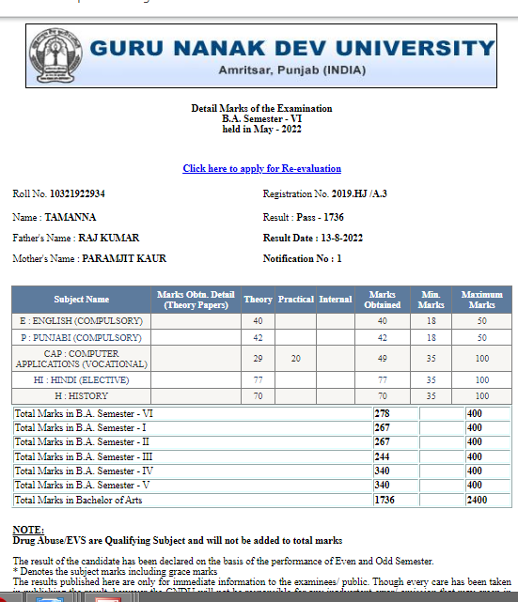
Riya | 6197 | B.A –VIth sem | 17/20 |  | Regular Class Test,Assignments, Seminars, Presentations , etc | 82/100 | 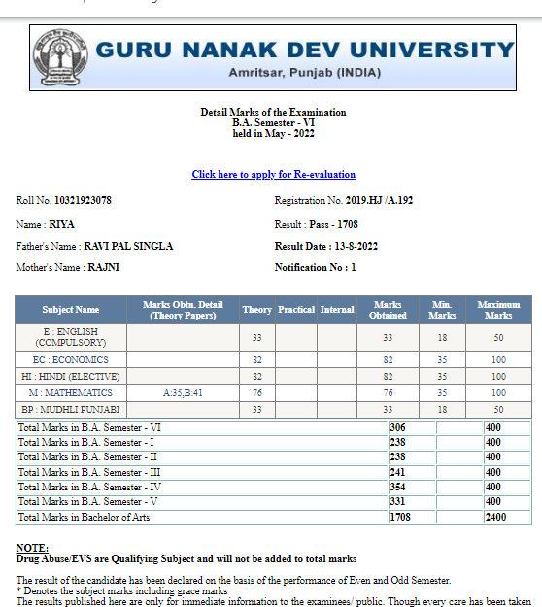
Prabhdeep Kaur | 16105 | M.A –I Sem | 18/20 | Hindi Sahitye Parishad | Regular Class Test,Assignments, Seminars, Presentations , etc Test | 364/400 | 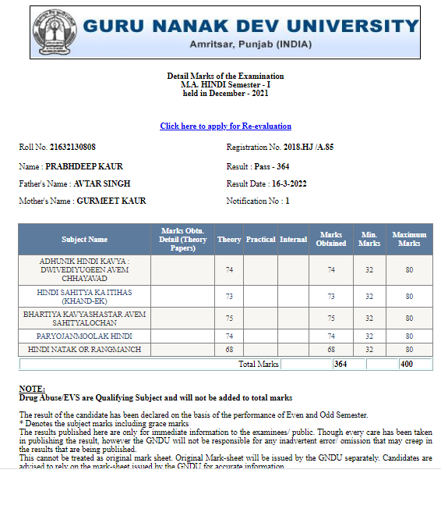
Taniya | 16110 | M.A –I Sem | 16/20 |  | Regular Class Test,Assignments, Seminars, Presentations , etc | 357/400 | 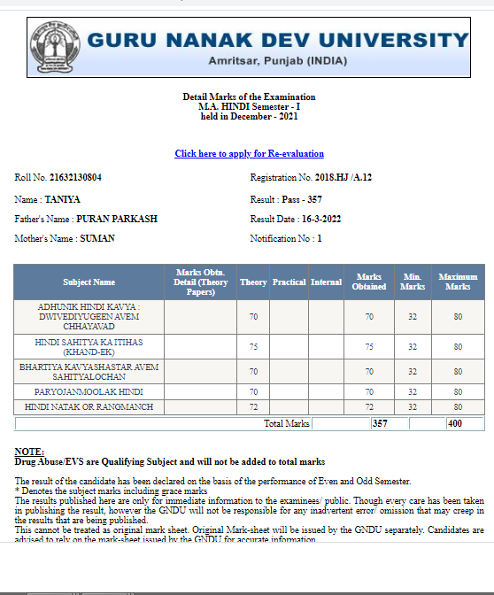
Prabhdeep Kaur | 16105 | M.A –II Sem | 18/20 |  | Regular Class Test,Assignments, Seminars, Presentations , etc | 317/400 | 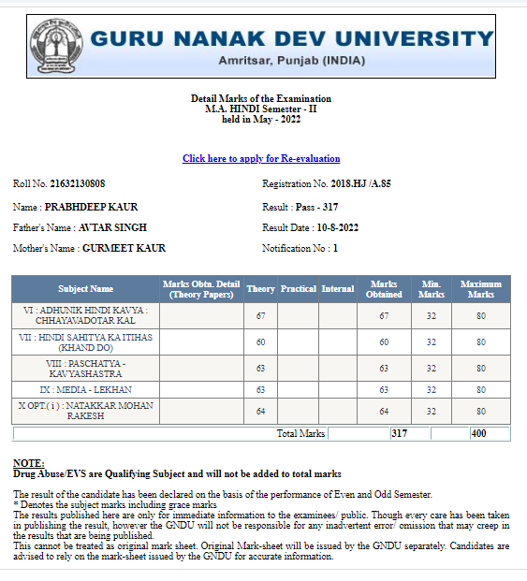
Rajni | 16112 | M.A –II Sem | 17/20 |  | Regular Class Test,Assignments, Seminars, Presentations , etc | 310/400 | 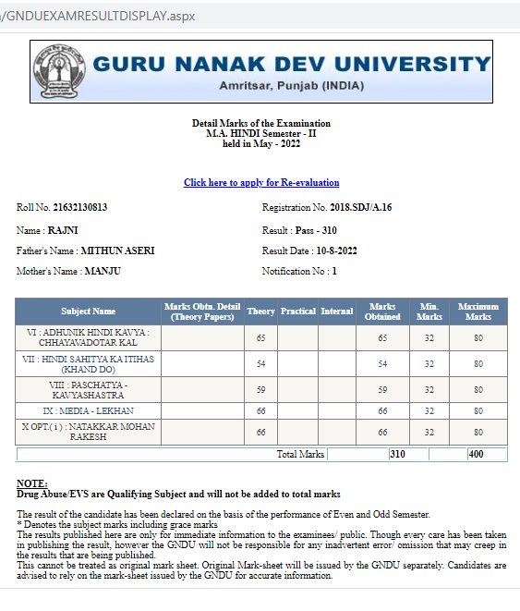
Ruksana Bano | 15107 | M.A –III Sem | 18/20 |  | Regular Class Test,Assignments, Seminars, Presentations , etc | 375/400 | 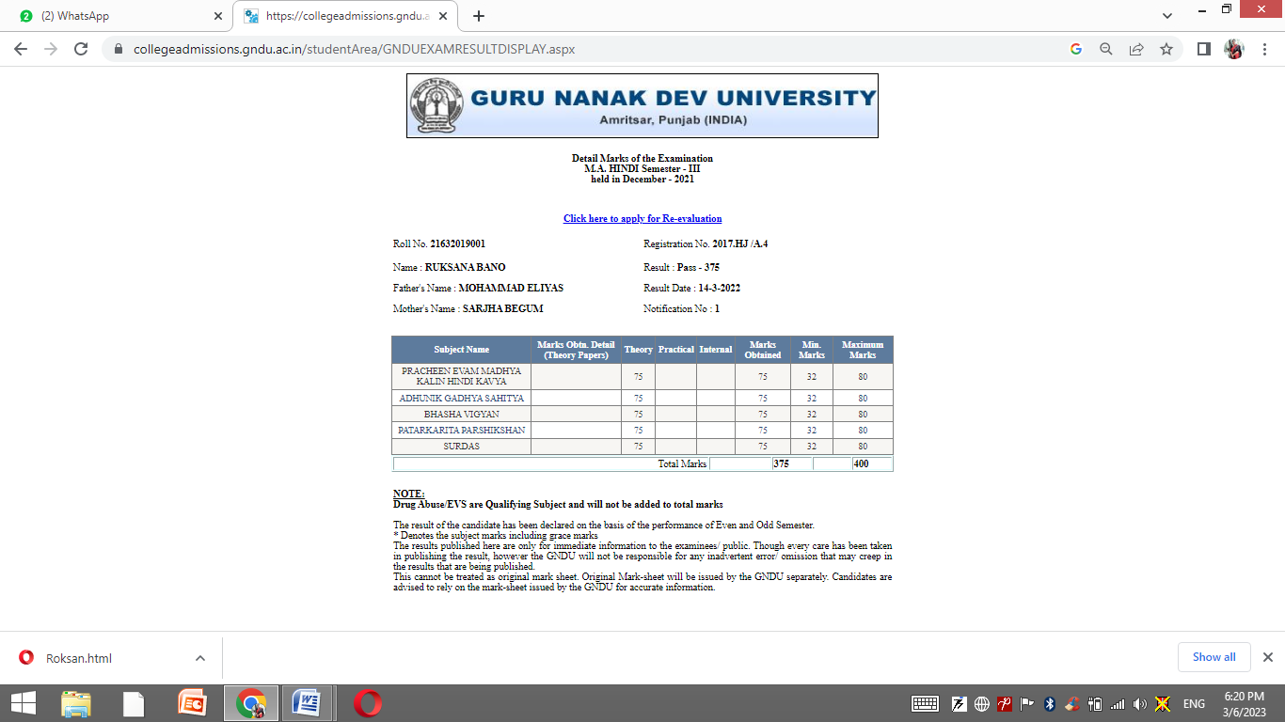
Chetna | 15101 | M.A –III Sem | 18/20 |  | Regular Class Test | 368/400 | 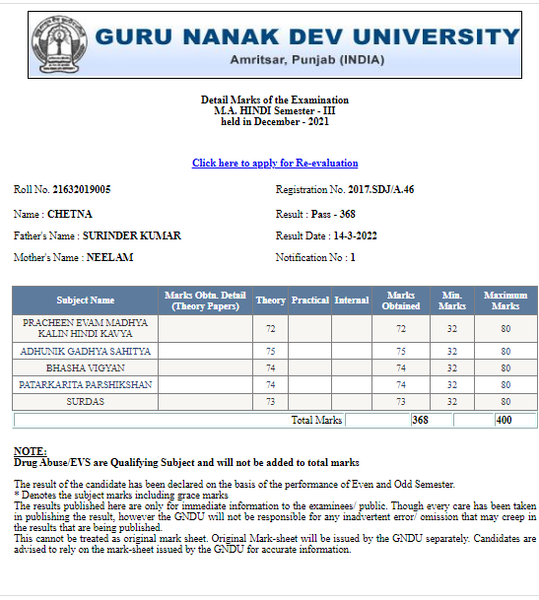
Preeti | 15105 | M.A –III Sem | 17/20 |  | Regular Class Test,Assignments, Seminars, Presentations , etc | 358/400 | 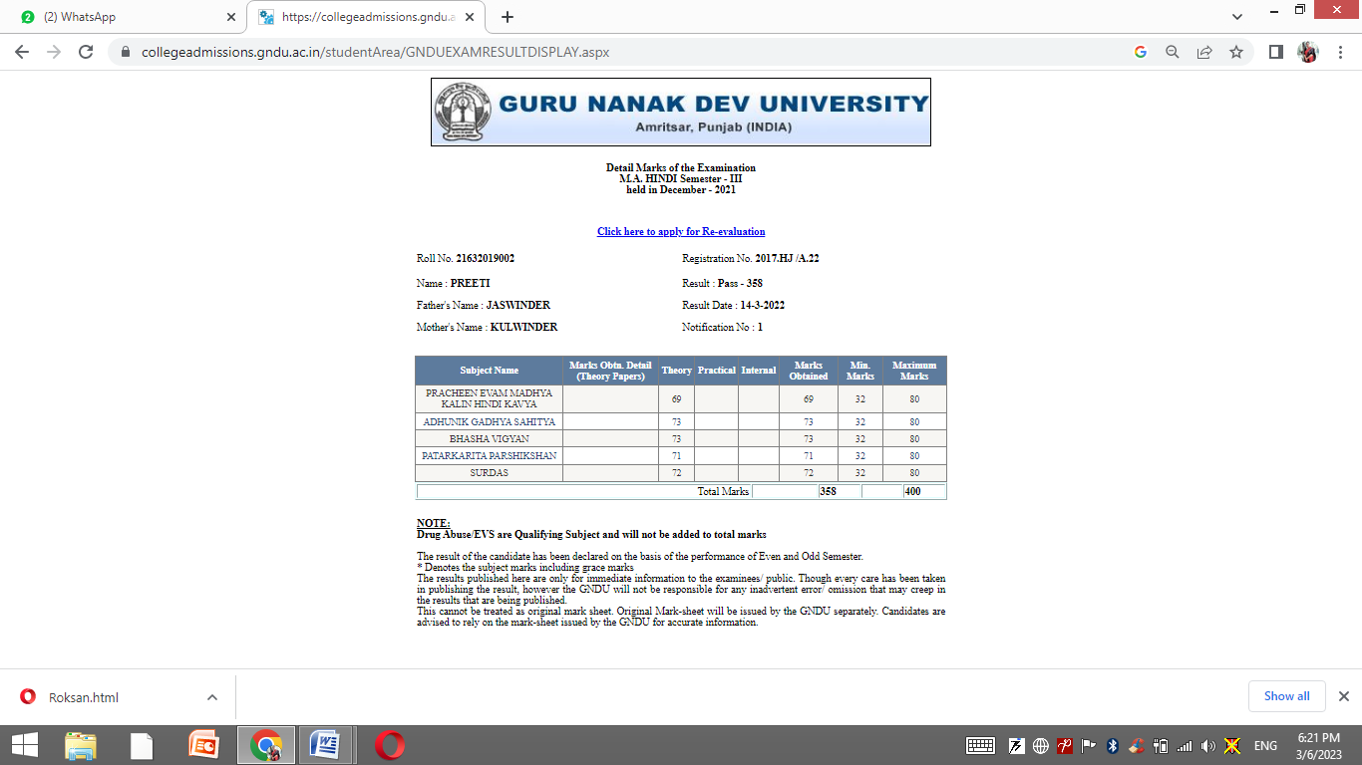
Ruksana Bano | 15107 | M.A –IV Sem | 18/20 |  | Regular Class Test,Assignments, Seminars, Presentations , etc | 341/400 | 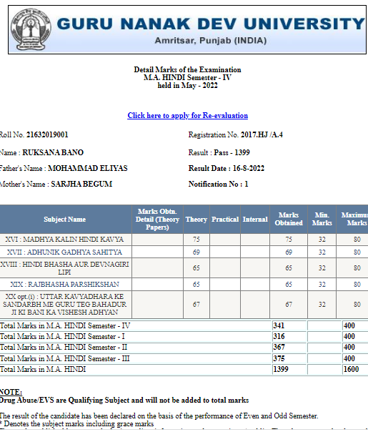
Chetna | 15101 | M.A –IV Sem | 18/20 |  | Regular Class Test,Assignments, Seminars, Presentations , etc | 331/400 | 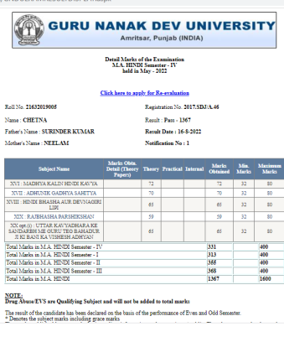
Preeti | 15105 | M.A –IV Sem | 17/20 |  | Regular Class Test,Assignments, Seminars, Presentations , etc | 317/400 | 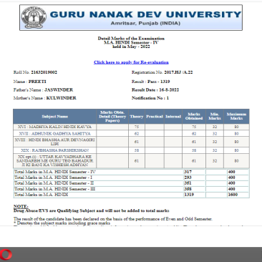

2021-22
PG DEPARTMENT OF HINDI
Slow Learners
Name of Student | Roll No. | Class | Marks in University Exams/House tests | Remedial Measures Taken | Outcome/ Achievements | Proofs (if any)
Nirmal | 10648 | B.A –I Sem | 06/20 | Regular class test/Video Lect,E- module etc | 55/100 | 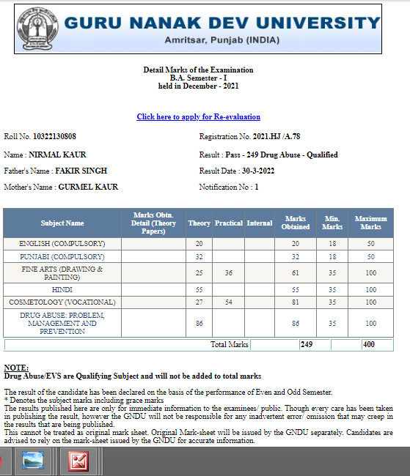
Anju | 10679 | B.A –I Sem | 01/20 | Regular class test/Video Lect,E- module etc | 47/100 | 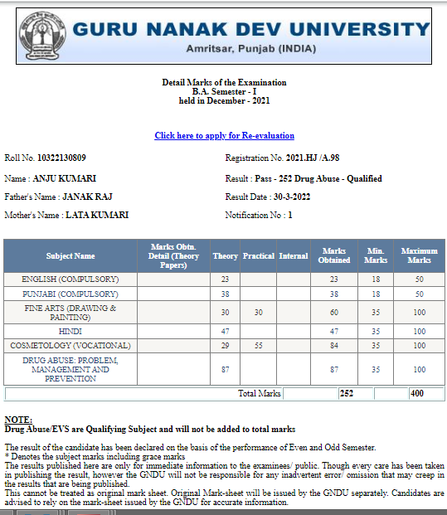
Shelly | 10707 | B.A –II Sem | 09/20 | Regular class test/Video Lect,E- module etc | 35/100 | 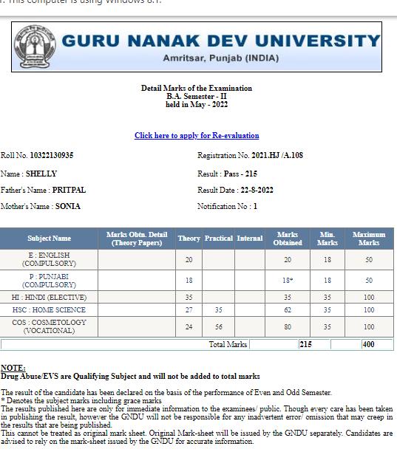
Nirmal | 10648 | B.A –II Sem | Ab | Regular class test/Video Lect,E- module etc | 35/100 | 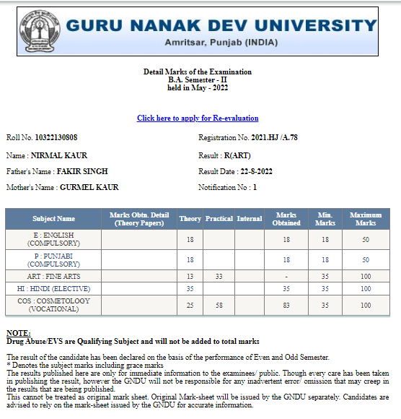
Nancy Dabla | 10056 | B.A –III Sem | 10/20 | Regular class test/Video Lect,E- module etc | 84/100 | 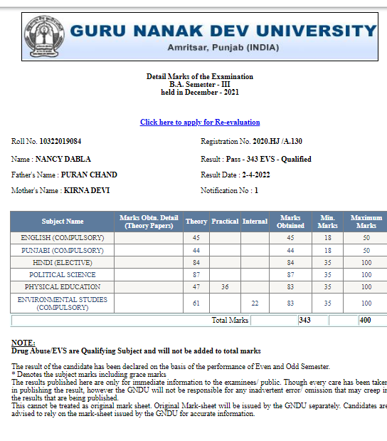
Geeta | 10064 | B.A –III Sem | 11/20 | Regular class test/Video Lect,E- module etc | 71/100 | 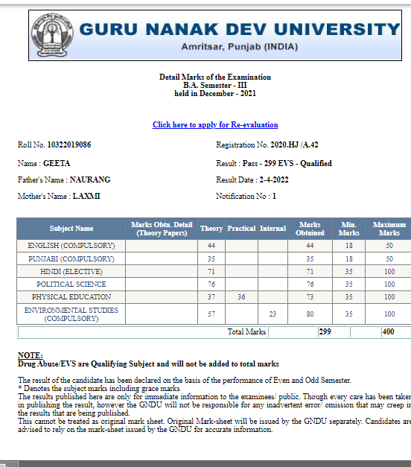
Nancy Dabla | 10056 | B.A – IV Sem | 09/20 | Regular class test/Video Lect,E- module etc | 60/100 | 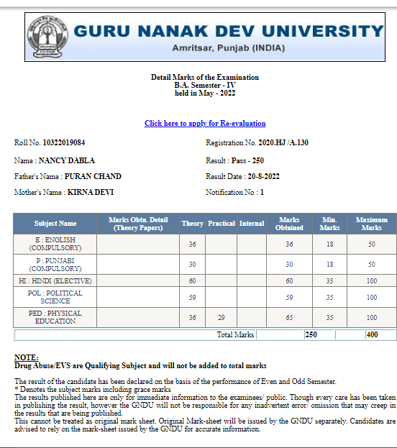
Geeta | 10064 | B.A – IV Sem | 10/20 | Regular class test/Video Lect,E- module etc | 35/100 | 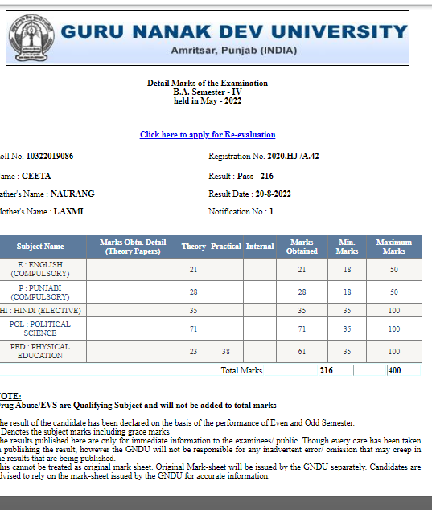
Priyanka | 6009 | B.A Vth Sem | 08/20 | Regular class test/Video Lect,E- module etc | 63/100 | 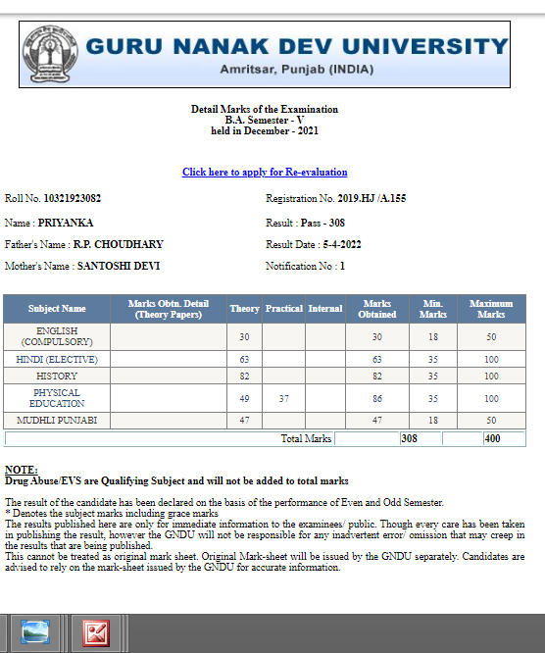
Manmeet Malhotra | 6181 | B.A – VI sem | 11/20 | Regular class test/Video Lect,E- module etc | 46/100 | 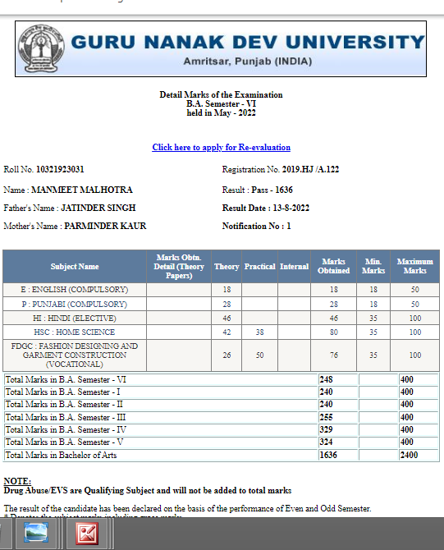
Kritika | 6051 | B.A – VI sem | 07/20 | Regular class test/Video Lect,E- module etc | 47/100 | 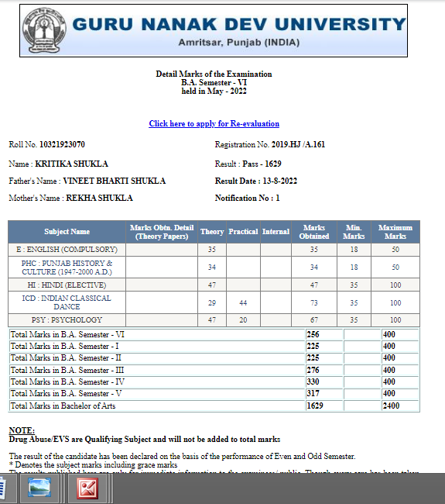
Shikha Kohli | 16103 | M.A –I sem | 10/20 | Regular class test/Video Lect,E- module etc | 297/400 | 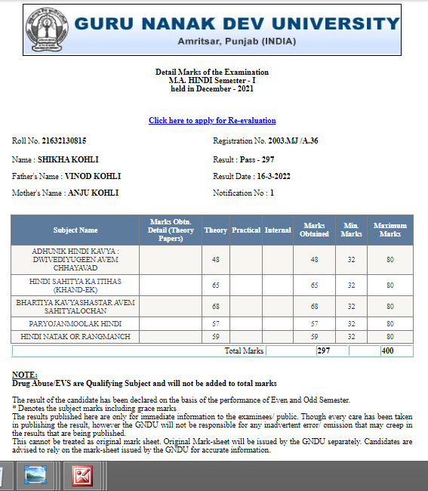
Muskan | 16116 | M.A –I sem | 11/20 | Regular class test/Video Lect,E- module etc | 251/400 | 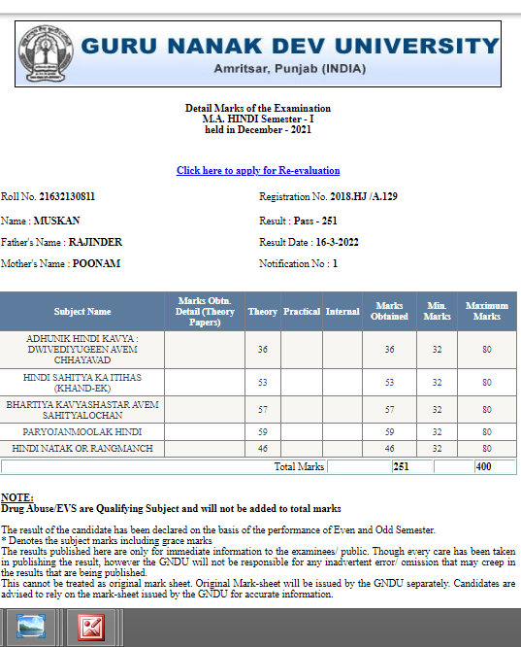
Shikha Kohli | 16103 | M.A –II sem | 09/20 | Regular class test/Video Lect,E- module etc | 250/400 | 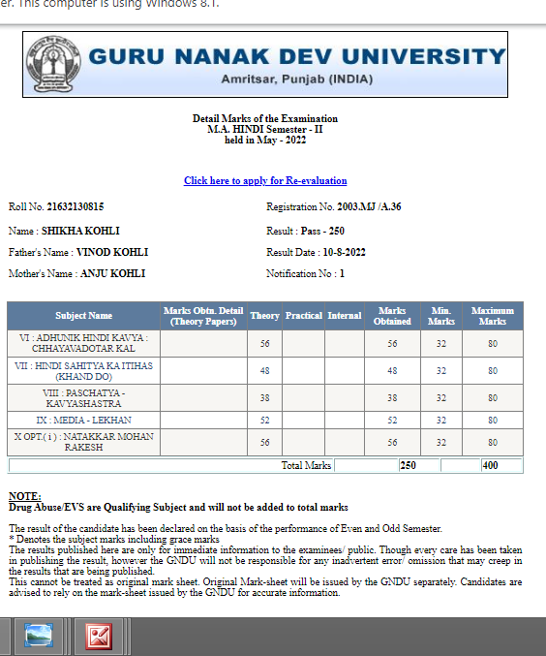
Monika | 16107 | M.A –II sem | 08/20 | Regular class test/Video Lect,E- module etc | 221/400 | 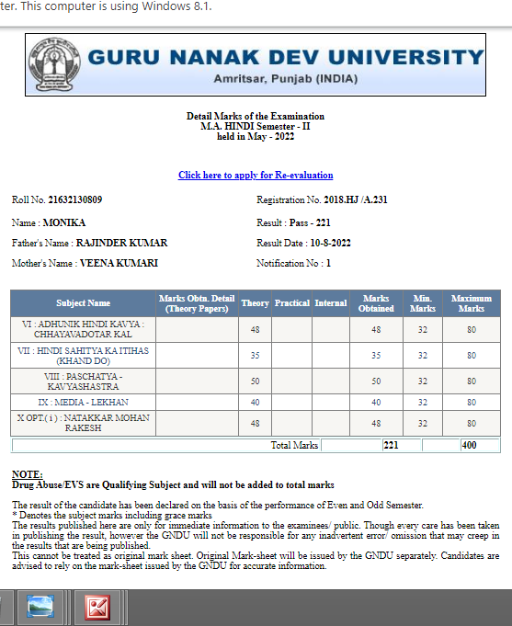
Roshni | 15103 | M.A –III sem | 09/20 | Regular class test/Video Lect,E- module etc | 309/400 | 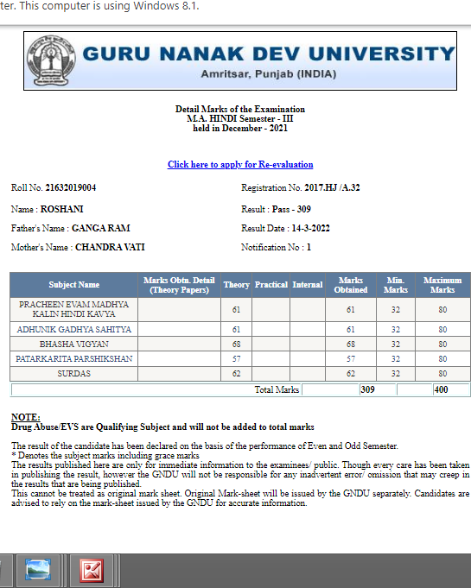
Sarita | 15108 | M.A III sem | 08/20 | Regular class test/Video Lect,E- module etc | 322/400 | 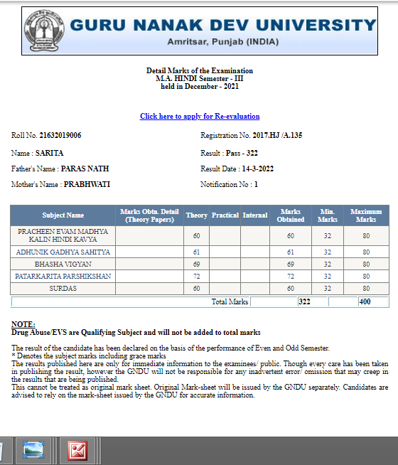
Sarita | 15108 | M.A IV sem | 10/20 | Regular class test/Video Lect,E- module etc | 306/400 | 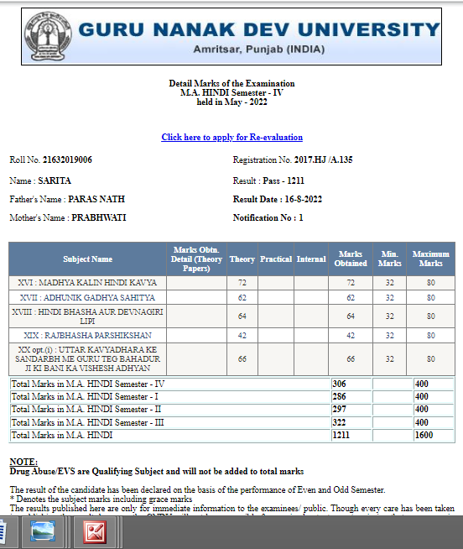
Roshni | 15103 | M.A –IV sem | 11/20 | Regular class test/Video Lect,E- module etc | 303/400 | 